# Algorithm for file updates in Python

## Project description

access to restricted content is controlled with an allow list of IP addresses. The "allow_list.txt" file identifies these IP addresses. A separate remove list identifies IP addresses that should no longer have access to this content. I created an algorithm to automate updating the "allow_list.txt" file and remove these IP addresses that should no longer have access.

## Open the file that contains the allow list

Import_file = “allow_list.txt”

With open(import_file, “r”) as file:

## Read the file contents

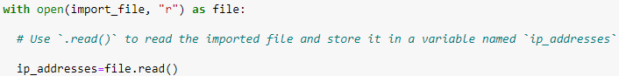

## Convert the string into a list

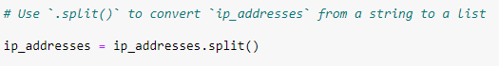

## Iterate through the remove list

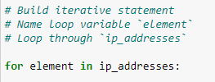

## Remove IP addresses that are on the remove list

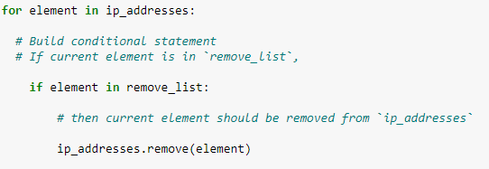

## Update the file with the revised list of IP addresses

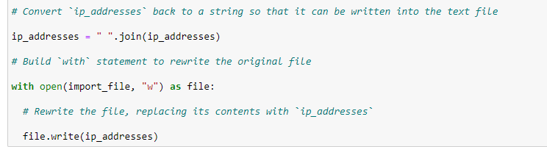

## Summary

This algorithm checks the “allow_list.txt” file for unauthorized IP addresses found in the remove_list, and will update the file by removing IP addresses that are listed on the remove_list. It begins by importing the alow_list.txt file, reading the file and converting the string data to list using .split(). After the data is converted to list then implementing an iteration of ip addresses in remove_ list, this is used to check whether the ip _ address matches with the remove_list or not. If matched we use the .remove() to remove the ip_address. After that, the updated list is converted back to a string and written back to the file.

By implementing this algorithm, we can efficiently manage access control lists, ensuring that only authorized employees have access to restricted content, which is crucial for maintaining data security and privacy in a healthcare environment.